Privilege Escalation Attack Detection and Mitigation in Cloud Using Machine Learning

INTRODUCTION
loud computing is a new way of thinking about how to facilitate and provide services through the Internet. The current financial crisis, as well as the expanding computing demands, have necessitated significant changes to the current Cloud Model in terms of data storage, processing, and display [1]. Cloud computing prevents people from spending a lot on equipment maintenance and purchases by utilizing cloud infrastructure. Cloud storage providers adopt fundamental security measures for their systems and the data they handle, including encryption, access control, and authentication. Depending on the accessibility, speed, and frequency of data access, the cloud has an almost infinite capacity for storing any type of data in different cloud data storage structures. Sensitive data breaches might occur due to the volume of data that moves between businesses and cloud service providers, both inadvertent and malicious. The characteristics that make online services easy to use for workers and IT systems also make it harder for businesses to prevent unwanted access [2]. Authentication and open Interfaces are new security vulnerabilities that Cloud services subject enterprises face. Hackers with advanced skills utilize their knowledge to access Cloud systems Machine learning employs a variety of approaches and algorithms to address the security challenge and better manage data. Many datasets are private and cannot be released owing to privacy concerns, or they may be missing crucial statistical properties [3], [4]. The fast rise of the Cloud industry creates privacy and security risks governed by regulations. Employee access privileges may not necessarily change when they change roles or positions within the Cloud Company. As a result, old privileges are used inconveniently to steal and harm valuable data. Each account that communicates with a computer has some level of authority. Server databases, confidential files, and other services are often restricted to approved users. A malicious attacker can access a sensitive system by gaining control of a higher user account and exploiting or expanding privileges. Based on their objectives, attackers can move horizontally to obtain control of more systems or vertically to obtain admin and root access till they have complete control of the whole environment [1]. When a user gets the access permissions of another user with the same access level, this is known as horizontal privilege escalation. An attacker can use horizontal privilege escalation to access data that does not necessarily relate to him. An attacker may be able to uncover holes in a Web application that provides him entry to certain other people’s information in badly designed apps [3], [5]. Because the attacker has completed a horizontal elevation of privileges exploit, they can see, alter, and copy sensitive information. Figure 1 illustrates the scenario of how the horizontal privilege escalation attack happened among the entities of the organizations. This form of assault usually necessitates a thorough knowledge of the weaknesses that impact specific operating systems and the usage of malicious programs. It’s also called privilege elevation assault, which entails giving a user, software, or other assets more rights or privileged access than they already have. Moving from a low degree of privileged access to a greater level of special access is the key objective of the attacker [6]. To achieve vertical access control, the attacker may need to take various actions to overcome or override security restrictions. Vertical privileges controls are finer-grained versions of security models that implement business objectives like separation of roles and least privilege, as shown in Figure 2. An attacker, for example, takes control of an ordinary registered user on a network and tries to acquire administrative or root access. Anomaly activity on organizational systems or user accounts can be detected using behavioral analytics, which might signal intrusion or privilege escalation.
1.1 Objective of the project:
Because of the recent exponential rise in attack frequency and sophistication, the proliferation of smart things has created significant cybersecurity challenges. Even though the tremendous changes cloud computing has brought to the business world, its centralization makes it challenging to use distributed services like security systems. Valuable data breaches might occur due to the high volume of data that moves between businesses and cloud service suppliers, both accidental and malicious. The malicious insider becomes a crucial threat to the organization since they have more access and opportunity to produce significant damage. Unlike outsiders, insiders possess privileged and proper access to information and resources. In this work, a machine learning-based system for insider threat detection and classification is proposed and developed a systematic approach to identify various anomalous occurrences that may point to anomalies and security problems associated with privilege escalation. By combining many models, ensemble learning enhances machine learning outcomes and enables greater prediction performance. Multiple studies have been presented regarding detecting irregularities and vulnerabilities in network systems to find security flaws or threats involving privilege escalation. But these studies lack the proper identification of the attacks. This study proposes and evaluates ensembles of Machine learning (ML) techniques in this context. This paper implements machine learning algorithms for the classification of insider attacks. A customized dataset from multiple files of the CERT dataset is used. Four machine learning algorithms, i.e., Random Forest (RF), Adaboost, XGBoost, and LightGBM, are applied to that dataset and analyzed results. Overall, LightGBM performed best. However, some other algorithms, such as RF or AdaBoost, may perform better on some internal attacks (Behavioral Biometrics attacks) or other internal attacks. Therefore, there is room for incorporating more than one machine learning algorithm to obtain a stronger classification in multiple internal attacks. Among the proposed algorithms, the LightGBM algorithm provides the highest accuracy of 97%; the other accuracy values are RF at 86%, AdaBoost at 88%, and XGBoost at 88.27%.
2. LITERATURE SURVEY:

Cloud-based email phishing attack using machine and deep learning algorithm

Cloud computing refers to the on-demand availability of personal computer system assets, specifically data storage and processing power, without the client's input. Emails are commonly used to send and receive data for individuals or groups. Financial data, credit reports, and other sensitive data are often sent via the Internet. Phishing is a fraudster's technique used to get sensitive data from users by seeming to come from trusted sources. The sender can persuade you to give secret data by misdirecting in a phished email. The main problem is email phishing attacks while sending and receiving the email. The attacker sends spam data using email and receives your data when you open and read the email. In recent years, it has been a big problem for everyone. This paper uses different legitimate and phishing data sizes, detects new emails, and uses different features and algorithms for classification. A modified dataset is created after measuring the existing approaches. We created a feature extracted comma-separated values (CSV) file and label file, applied the support vector machine (SVM), Naive Bayes (NB), and long short-term memory (LSTM) algorithm. This experimentation considers the recognition of a phished email as a classification issue. According to the comparison and implementation, SVM, NB and LSTM performance is better and more accurate to detect email phishing attacks. The classification of email attacks using SVM, NB, and LSTM classifiers achieve the highest accuracy of 99.62%, 97% and 98%, respectively.

Machine learning based Insider Threat Modelling and Detection

Recently, malicious insider attacks represent one of the most damaging threats to companies and government agencies. This paper proposes a new framework in constructing a user-centered machine learning based insider threat detection system on multiple data granularity levels. System evaluations and analysis are performed not only on individual data instances but also on normal and malicious insiders, where insider scenario specific results and delay in detection are reported and discussed. Our results show that the machine learning based detection system can learn from limited ground truth and detect new malicious insiders with a high accuracy.

Survey on Security Issues in Cloud Computing and Associated Mitigation Techniques

Cloud Computing holds the potential to eliminate the requirements for setting up of high-cost computing infrastructure for IT-based solutions and services that the industry uses. It promises to provide a flexible IT architecture, accessible through internet for lightweight portable devices. This would allow multi-fold increase in the capacity or capabilities of the existing and new software. In a cloud computing environment, the entire data reside over a set of networked resources, enabling the data to be accessed through virtual machines. Since these data-centers may lie in any corner of the world beyond the reach and control of users, there are multifarious security and privacy challenges that need to be understood and taken care of. Also, one can never deny the possibility of a server breakdown that has been witnessed, rather quite often in the recent times. There are various issues that need to be dealt with respect to security and privacy in a cloud computing scenario. This extensive survey paper aims to elaborate and analyze the numerous unresolved issues threatening the cloud computing adoption and diffusion affecting the various stake-holders linked to it

Cloud computing platform: Performance analysis of prominent cryptographic algorithms

With advancements in science and technology, cloud computing is the next big thing in the industry. Cloud cryptography is a technique that uses encryption algorithms to secure data. The significant advantage of cloud storage is no difficulty to get to, diminished equipment, low protection, and fixing cost so every association is working with the cloud. Encryption is the process of encoding information to prevent unauthorized access. Nowadays, we desire to secure the information that is to be stored in our computer or transmitted utilizing the internet against attacks. The cryptographic method depends on their response time, confidentiality, bandwidth, and integrity. Furthermore, security is a significant factor in cloud computing for ensuring client data is placed on the safe mode in the cloud. Our research paper compares the efficiency, usage, and utility of available cryptography algorithms. Evaluation results suggest which algorithm is better for which type of data and environment.

Cloud Security Threats and Solutions: A Survey

Cloud computing is the on-demand availability of PC framework resources. Especially information storage and handling power, without direct unique administration by the customer. It has provided customers with public and private computing and data storage on a single platform across the Internet. Aside from that, it faces several security threats and issues, which may slow down the adoption of cloud computing models. Cloud computing security threats, difficulties, strategies, and solutions are discussed in this paper. Numerous people raised security concerns in a previous survey. Another survey looks at the cloud computing architectural model, and a few of them detail security challenges and techniques. This article brings together all the security concerns, difficulties, techniques, and solutions in one place.

Security Problems in Smart Homes

The development of technologies in smart homes today, snip attention of many researchers due to the importance that these smart homes can bring to human beings. Smart homes are used to improve everyday life like monitoring (homes, children, old people and patients in hospital), home security, smart hospitals and automation in many buildings. However, there are many security problems and challenges that still persisting in smart homes, and these, somehow makes smart homes be vulnerable not only for their residents, but also to the manufacturers of smart devices. There are different situations like cyber-attacks, implantation of spy devices or the complete modification of data happening with frequency in smart home applications. We also analyze some opening issues like data integrity, confidentiality, non-repudiation and so on, to improve security of residents. Approaches of these problems, the techniques for their minimization, and at the end, solutions are brought to the efficient working principles of smart homes.

Ensemble Strategy for Insider Threat Detection from User Activity Logs

The authors use Local Outlier Factor (LOF) to perform the oversampling. Some other recent works include random oversampling of the training set with various sampling ratios following a binary classification for each scenario, generating manually augmented data using an existing dataset to create an augmented dataset , spread sub-sampling method and SMOTE based data adjustment The method gave best results for Scenario 2 on RF whereas it could not perform satisfactorily on Scenarios 1 and 2. But our experiments on scenario-based binary classification using CGAN data augmentation gives better results for each scenario. An ensemble strategy combined with data adjusted XGBoost model for insider threat detection proposed in gave promising results with an average recall of 98.5% which is similar to our binary classification results.

On the effectiveness of machine and deep learning for cyber security

Machine learning is adopted in a wide range of domains where it shows its superiority over traditional rule-based algorithms. These methods are being integrated in cyber detection systems with the goal of supporting or even replacing the first level of security analysts. Although the complete automation of detection and analysis is an enticing goal, the efficacy of machine learning in cyber security must be evaluated with the due diligence. We present an analysis, addressed to security specialists, of machine learning techniques applied to the detection of intrusion, malware, and spam. The goal is twofold: to assess the current maturity of these solutions and to identify their main limitations that prevent an immediate adoption of machine learning cyber detection schemes. Our conclusions are based on an extensive review of the literature as well as on experiments performed on real enterprise systems and network traffic.
3. SYSTEM ANALYSIS
3.1EXISTING SYSTEM
The malicious insider becomes a crucial threat to the organization since they have more access and opportunity to produce significant damage. Unlike outsiders, insiders possess privileged and proper access to information and resources. In this work, a machine learning-based system for insider threat detection and classification is proposed and developed a systematic approach to identify various anomalous occurrences that may point to anomalies and security problems associated with privilege escalation. By combining many models, ensemble learning enhances machine learning outcomes and enables greater prediction performance. Multiple studies have been presented regarding detecting irregularities and vulnerabilities in network systems to find security flaws or threats involving privilege escalation
Disadvantages:
- 1. Lack of proper identification of the attacks
- Less Security

3.2 PROPOSED SYSTEM

Advantages:
In propose paper to detect such insider attacks author of this paper employing ensemble machine learning algorithms such as Random Forest, LIGHTGBM, XGBOOST and ADABOOST. Among all algorithms LIGHTGBM is giving better accuracy and each algorithm performance is evaluated in terms of confusion matrix, accuracy, precision, recall and FSCORE
In propose paper author has used all traditional Ensemble algorithms so as extension we have utilized CATBOOST algorithm which is one of the advance ensemble algorithm and can give better accuracy
- Proper identification of the attacks
- More Security
Modules:
To implement this project we have designed following modules
- Upload CERT Database: using this module will upload dataset to application and then application will read all values and then visualize graph of normal and insider attacks
- Pre-process & Split Dataset: using this module will remove missing values and then shuffle and normalized values and then split into train and test where application using 80% dataset for training and 20% for testing
- Run Random Forest: 80% training data will be input to random forest algorithm to train a model and this model will be applied on 20% test data to calculate prediction accuracy.
- Run ADABOOST: 80% training data will be input to ADABOOST algorithm to train a model and this model will be applied on 20% test data to calculate prediction accuracy.
- Run XGBOOST: 80% training data will be input to XGBOOST algorithm to train a model and this model will be applied on 20% test data to calculate prediction accuracy.
- Run LIGHTGBM: 80% training data will be input to LIGHTGBM algorithm to train a model and this model will be applied on 20% test data to calculate prediction accuracy.
- Run Extension CATBOOST: 80% training data will be input to CATBOOST algorithm to train a model and this model will be applied on 20% test data to calculate prediction accuracy.
- Comparison Graph: will plot comparison graph between all algorithms

3.3. PROCESS MODEL USED WITH JUSTIFICATION
SDLC (Umbrella Model):
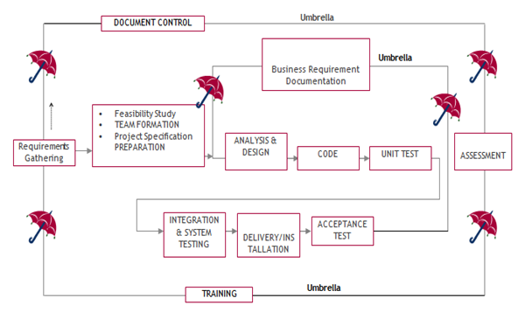
SDLC is nothing but Software Development Life Cycle. It is a standard which is used by software industry to develop good software.
Stages in SDLC:
- Requirement Gathering
- Analysis
- Designing
- Coding
- Testing
- Maintenance
Requirements Gathering stage:
The requirements gathering process takes as its input the goals identified in the high-level requirements section of the project plan. Each goal will be refined into a set of one or more requirements. These requirements define the major functions of the intended application, define operational data areas and reference data areas, and define the initial data entities. Major functions include critical processes to be managed, as well as mission critical inputs, outputs and reports. A user class hierarchy is developed and associated with these major functions, data areas, and data entities. Each of these definitions is termed a Requirement. Requirements are identified by unique requirement identifiers and, at minimum, contain a requirement title and textual description.
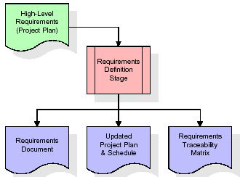
These requirements are fully described in the primary deliverables for this stage: the Requirements Document and the Requirements Traceability Matrix (RTM). The requirements document contains complete descriptions of each requirement, including diagrams and references to external documents as necessary. Note that detailed listings of database tables and fields are not included in the requirements document.
The title of each requirement is also placed into the first version of the RTM, along with the title of each goal from the project plan. The purpose of the RTM is to show that the product components developed during each stage of the software development lifecycle are formally connected to the components developed in prior stages.
In the requirements stage, the RTM consists of a list of high-level requirements, or goals, by title, with a listing of associated requirements for each goal, listed by requirement title. In this hierarchical listing, the RTM shows that each requirement developed during this stage is formally linked to a specific product goal. In this format, each requirement can be traced to a specific product goal, hence the term requirements traceability.
The outputs of the requirements definition stage include the requirements document, the RTM, and an updated project plan.
- Feasibility study is all about identification of problems in a project.
- No. of staff required to handle a project is represented as Team Formation, in this case only modules are individual tasks will be assigned to employees who are working for that project.
- Project Specifications are all about representing of various possible inputs submitting to the server and corresponding outputs along with reports maintained by administrator.
Analysis Stage:
The planning stage establishes a bird's eye view of the intended software product, and uses this to establish the basic project structure, evaluate feasibility and risks associated with the project, and describe appropriate management and technical approaches.
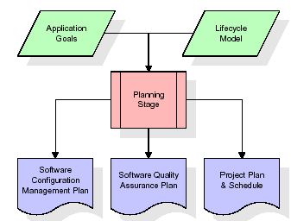
The most critical section of the project plan is a listing of high-level product requirements, also referred to as goals. All of the software product requirements to be developed during the requirements definition stage flow from one or more of these goals. The minimum information for each goal consists of a title and textual description, although additional information and references to external documents may be included. The outputs of the project planning stage are the configuration management plan, the quality assurance plan, and the project plan and schedule, with a detailed listing of scheduled activities for the upcoming Requirements stage, and high level estimates of effort for the out stages.
Designing Stage:
The design stage takes as its initial input the requirements identified in the approved requirements document. For each requirement, a set of one or more design elements will be produced as a result of interviews, workshops, and/or prototype efforts. Design elements describe the desired software features in detail, and generally include functional hierarchy diagrams, screen layout diagrams, tables of business rules, business process diagrams, pseudo code, and a complete entity-relationship diagram with a full data dictionary. These design elements are intended to describe the software in sufficient detail that skilled programmers may develop the software with minimal additional input.
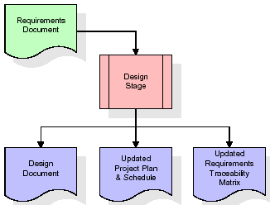
When the design document is finalized and accepted, the RTM is updated to show that each design element is formally associated with a specific requirement. The outputs of the design stage are the design document, an updated RTM, and an updated project plan.
Development (Coding) Stage:
The development stage takes as its primary input the design elements described in the approved design document. For each design element, a set of one or more software artifacts will be produced. Software artifacts include but are not limited to menus, dialogs, and data management forms, data reporting formats, and specialized procedures and functions. Appropriate test cases will be developed for each set of functionally related software artifacts, and an online help system will be developed to guide users in their interactions with the software.
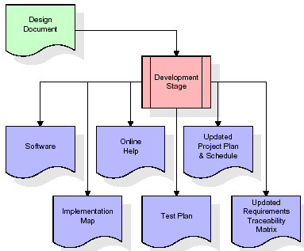

The RTM will be updated to show that each developed artifact is linked to a specific design element, and that each developed artifact has one or more corresponding test case items. At this point, the RTM is in its final configuration. The outputs of the development stage include a fully functional set of software that satisfies the requirements and design elements previously documented, an online help system that describes the operation of the software, an implementation map that identifies the primary code entry points for all major system functions, a test plan that describes the test cases to be used to validate the correctness and completeness of the software, an updated RTM, and an updated project plan.
Integration & Test Stage:
During the integration and test stage, the software artifacts, online help, and test data are migrated from the development environment to a separate test environment. At this point, all test cases are run to verify the correctness and completeness of the software. Successful execution of the test suite confirms a robust and complete migration capability. During this stage, reference data is finalized for production use and production users are identified and linked to their appropriate roles. The final reference data (or links to reference data source files) and production user list are compiled into the Production Initiation Plan.
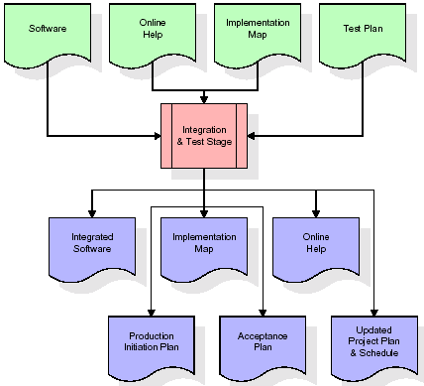
The outputs of the integration and test stage include an integrated set of software, an online help system, an implementation map, a production initiation plan that describes reference data and production users, an acceptance plan which contains the final suite of test cases, and an updated project plan.
- Installation & Acceptance Test:
During the installation and acceptance stage, the software artifacts, online help, and initial production data are loaded onto the production server. At this point, all test cases are run to verify the correctness and completeness of the software. Successful execution of the test suite is a prerequisite to acceptance of the software by the customer.
After customer personnel have verified that the initial production data load is correct and the test suite has been executed with satisfactory results, the customer formally accepts the delivery of the software.
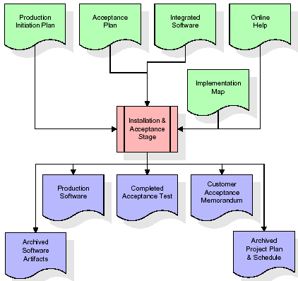
The primary outputs of the installation and acceptance stage include a production application, a completed acceptance test suite, and a memorandum of customer acceptance of the software. Finally, the PDR enters the last of the actual labor data into the project schedule and locks the project as a permanent project record. At this point the PDR "locks" the project by archiving all software items, the implementation map, the source code, and the documentation for future reference.
Maintenance:
Outer rectangle represents maintenance of a project, Maintenance team will start with requirement study, understanding of documentation later employees will be assigned work and they will undergo training on that particular assigned category. For this life cycle there is no end, it will be continued so on like an umbrella (no ending point to umbrella sticks).
3.4. Software Requirement Specification
3.4.1. Overall Description
A Software Requirements Specification (SRS) – a requirements specification for a software system is a complete description of the behaviour of a system to be developed. It includes a set of use cases that describe all the interactions the users will have with the software. In addition to use cases, the SRS also contains non-functional requirements. Non-functional requirements are requirements which impose constraints on the design or implementation (such as performance engineering requirements, quality standards, or design constraints).
System requirements specification: A structured collection of information that embodies the requirements of a system. A business analyst, sometimes titled system analyst, is responsible for analysing the business needs of their clients and stakeholders to help identify business problems and propose solutions. Within the systems development lifecycle domain, the BA typically performs a liaison function between the business side of an enterprise and the information technology department or external service providers. Projects are subject to three sorts of requirements:
- Business requirements describe in business terms what must be delivered or accomplished to provide value.
- Product requirements describe properties of a system or product (which could be one of several ways to accomplish a set of business requirements.)
- Process requirements describe activities performed by the developing organization. For instance, process requirements could specify .Preliminary investigation examine project feasibility, the likelihood the system will be useful to the organization. The main objective of the feasibility study is to test the Technical, Operational and Economical feasibility for adding new modules and debugging old running system. All system is feasible if they are unlimited resources and infinite time. There are aspects in the feasibility study portion of the preliminary investigation:
- ECONOMIC FEASIBILITY
A system can be developed technically and that will be used if installed must still be a good investment for the organization. In the economical feasibility, the development cost in creating the system is evaluated against the ultimate benefit derived from the new systems. Financial benefits must equal or exceed the costs. The system is economically feasible. It does not require any addition hardware or software. Since the interface for this system is developed using the existing resources and technologies available at NIC, There is nominal expenditure and economical feasibility for certain.
- Operational Feasibility
Proposed projects are beneficial only if they can be turned out into information system. That will meet the organization’s operating requirements. Operational feasibility aspects of the project are to be taken as an important part of the project implementation. This system is targeted to be in accordance with the above-mentioned issues. Beforehand, the management issues and user requirements have been taken into consideration. So there is no question of resistance from the users that can undermine the possible application benefits. The well-planned design would ensure the optimal utilization of the computer resources and would help in the improvement of performance status.
- TECHNICAL FEASIBILITY
Earlier no system existed to cater to the needs of ‘Secure Infrastructure Implementation System’. The current system developed is technically feasible. It is a web-based user interface for audit workflow at NIC-CSD. Thus, it provides an easy access to. the users. The database’s purpose is to create, establish and maintain a workflow among various entities in order to facilitate all concerned users in their various capacities or roles. Permission to the users would be granted based on the roles specified. Therefore, it provides the technical guarantee of accuracy, reliability and security.
3.4.2. External Interface Requirements
User Interface
The user interface of this system is a user friendly python Graphical User Interface.
Hardware Interfaces
The interaction between the user and the console is achieved through python capabilities.
Software Interfaces
The required software is python.
SYSTEM REQUIREMENT:
HARDWARE REQUIREMENTS:

Processor - Intel i3(min)
- Speed - 1.1 GHz(min)
- RAM - 4GB(min)
- Hard Disk - 500 GB
SOFTWARE REQUIREMENTS:
- Operating System - Windows10(min)
- Programming Language - Python 3.7.0
4. SYSTEM DESIGN
UML Diagram:
The Unified Modelling Language allows the software engineer to express an analysis model using the modelling notation that is governed by a set of syntactic semantic and pragmatic rules.
A UML system is represented using five different views that describe the system from distinctly different perspective. Each view is defined by a set of diagram, which is as follows.
  - User Model View
    - This view represents the system from the users perspective.
    - The analysis representation describes a usage scenario from the end-users perspective.
  - Structural Model view
    - In this model the data and functionality are arrived from inside the system.
    - This model view models the static structures.
- Behavioural Model View
It represents the dynamic of behavioural as parts of the system, depicting the interactions of collection between various structural elements described in the user model and structural model view.
- Implementation Model View
In this the structural and behavioural as parts of the system are represented as they are to be built.
- Environmental Model View
In this the structural and behavioural aspects of the environment in which the system is to be implemented are represented.
Class Diagram:
The class diagram is the main building block of object oriented modeling. It is used both for general conceptual modeling of the systematic of the application, and for detailed modeling translating the models into programming code. Class diagrams can also be used for data modeling. The classes in a class diagram represent both the main objects, interactions in the application and the classes to be programmed. In the diagram, classes are represented with boxes which contain three parts:
- The upper part holds the name of the class
- The middle part contains the attributes of the class
- The bottom part gives the methods or operations the class can take or undertake.

Use case Diagram:
A use case diagram at its simplest is a representation of a user's interaction with the system and depicting the specifications of a use case. A use case diagram can portray the different types of users of a system and the various ways that they interact with the system. This type of diagram is typically used in conjunction with the textual use case and will often be accompanied by other types of diagrams as well.

Sequence diagram:
A sequence diagram is a kind of interaction diagram that shows how processes operate with one another and in what order. It is a construct of a Message Sequence Chart. A sequence diagram shows object interactions arranged in time sequence. It depicts the objects and classes involved in the scenario and the sequence of messages exchanged between the objects needed to carry out the functionality of the scenario. Sequence diagrams are typically associated with use case realizations in the Logical View of the system under development. Sequence diagrams are sometimes called event diagrams, event scenarios, and timing diagrams.

Collaboration diagram:
A collaboration diagram describes interactions among objects in terms of sequenced messages. Collaboration diagrams represent a combination of information taken from class, sequence, and use case diagrams describing both the static structure and dynamic behaviour of a system.

Component Diagram:
In the Unified Modelling Language, a component diagram depicts how components are wired together to form larger components and or software systems. They are used to illustrate the structure of arbitrarily complex systems.
Components are wired together by using an assembly connector to connect the required interface of one component with the provided interface of another component. This illustrates the service consumer - service provider relationship between the two components.

Deployment Diagram:
A deployment diagram in the Unified Modeling Language models the physical deployment of artifacts on nodes. To describe a web site, for example, a deployment diagram would show what hardware components ("nodes") exist (e.g., a web server, an application server, and a database server), what software components ("artifacts") run on each node (e.g., web application, database), and how the different pieces are connected (e.g. JDBC, REST, RMI).
The nodes appear as boxes, and the artifacts allocated to each node appear as rectangles within the boxes. Nodes may have sub nodes, which appear as nested boxes. A single node in a deployment diagram may conceptually represent multiple physical nodes, such as a cluster of database servers.
Activity Diagram:

Activity diagram is another important diagram in UML to describe dynamic aspects of the system. It is basically a flow chart to represent the flow form one activity to another activity. The activity can be described as an operation of the system. So the control flow is drawn from one operation to another. This flow can be sequential, branched or concurrent
Upload CERT Database
Pre-process & Split Dataset
Run ADABOOST

Run Random Forest

Run XGBOOST
Run LIGHTGBM
Comparison Graph

Run Extension CATBOOST

Predict Action

Data Flow Diagram:
Data flow diagrams illustrate how data is processed by a system in terms of inputs and outputs. Data flow diagrams can be used to provide a clear representation of any business function. The technique starts with an overall picture of the business and continues by analyzing each of the functional areas of interest. This analysis can be carried out in precisely the level of detail required. The technique exploits a method called top-down expansion to conduct the analysis in a targeted way.
As the name suggests, Data Flow Diagram (DFD) is an illustration that explicates the passage of information in a process. A DFD can be easily drawn using simple symbols. Additionally, complicated processes can be easily automated by creating DFDs using easy-to-use, free downloadable diagramming tools. A DFD is a model for constructing and analyzing information processes. DFD illustrates the flow of information in a process depending upon the inputs and outputs. A DFD can also be referred to as a Process Model. A DFD demonstrates business or technical process with the support of the outside data saved, plus the data flowing from the process to another and the end results
User

1. Upload CERT Database 2. Successfully Upload CERT Database
3. Pre-process & Split Dataset 4.Successfully Pre-process & Split Dataset
5. Run Random Forest 6.Successfully Run Random Forest
7. Run ADABOOST 8. Successfully Run ADABOOST
9. Run XGBOOST 10. Successfully Run XGBOOST
11. Run LIGHTGBM 12.Successfully Run LIGHTGBM
13. Run Extension CATBOOST 14.Successfully Run Extension CATBOOST
15. Comparison Graph 16. Successfully Comparison Graph
17. Predict Action 18. Predict Action Successfully
system

5. IMPLEMETATION
5.1 PYTHON
* One of the most popular languages is Python. Guido van Rossum released this language in 1991. Python is available on the Mac, Windows, and Raspberry Pi operating systems. The syntax of Python is simple and identical to that of English. When compared to Python, it was seen that the other language requires a few extra lines.
*It is an interpreter-based language because code may be run line by line after it has been written. This implies that rapid prototyping is possible across all platforms. Python is a big language with a free, binary-distributed interpreter standard library.
* It is inferior to maintenance that is conducted and is straightforward to learn. It is an object-oriented, interpreted programming language. It supports several different programming paradigms in addition to object-oriented programming, including functional and procedural programming.
* It supports several different programming paradigms in addition to object-oriented programming, including practical and procedural programming. Python is mighty while maintaining a relatively straightforward syntax. Classes, highly dynamic data types, modules, and exceptions are covered. Python can also be utilised by programmes that require programmable interfaces as an external language.
Here are some key features and characteristics of Python:
- Readability: Python emphasizes code readability with its clean and intuitive syntax. It uses indentation and whitespace to structure code blocks, making it easy to understand and maintain.
- Easy to Learn: Python's simplicity and readability make it an excellent choice for beginners. Its straightforward syntax and extensive documentation make it accessible for newcomers to programming.
- Interpreted Language: Python is an interpreted language, meaning that it doesn't need to be compiled before running. The Python interpreter reads and executes the code directly, making the development process faster and more interactive.
- Cross-platform Compatibility: Python is available for major operating systems like Windows, macOS, and Linux. This cross-platform compatibility allows developers to write code once and run it on different platforms without modifications.
- Large Standard Library: Python comes with a vast standard library that provides ready-to-use modules and functions for various tasks. It covers areas such as file I/O, networking, regular expressions, databases, and more, saving developers time and effort.
- Extensible and Modular: Python supports modular programming, enabling developers to organize code into reusable modules and packages. Additionally, Python allows integrating modules written in other languages, such as C or C++, providing flexibility and performance optimizations.
- Wide Range of Libraries and Frameworks: Python has a vibrant ecosystem with numerous third-party libraries and frameworks. These libraries, such as NumPy, pandas, Tensor Flow, and Django, extend Python's capabilities for specific domains, making it a powerful tool for diverse applications.
- Object-Oriented: Python supports object-oriented programming (OOP) principles, allowing developers to create and work with classes and objects. OOP provides a structured approach to code organization, promoting code reuse and modularity.
- Dynamic Typing: Python is dynamically typed, meaning variable types are determined at runtime. Developers do not need to declare variable types explicitly, which enhances flexibility and simplifies code writing.
5.2 Installation
To install Python on your computer, follow these basic steps:
- Step 1: Visit the Python website Go to the official Python website at https://www.python.org/.
- Step 2: Select the operating system Choose the appropriate installer for your operating system. Python supports Windows, macOS, and various Linux distributions. Make sure to select the correct version that matches your operating system.
- Step 3: Check which version of Python is installed; if the 3.7.0 version is not there, uninstall it through the control panel and
- Step 4: Install Python 3.7.0 using Cmd.
- Step 5: Install the all libraries that required to run the project
- Step 6: Run
5.3 Python Features:
- Easy: Because Python is a more accessible and straightforward language, Python programming is easier to learn.
- Interpreted language: Python is an interpreted language, therefore it can be used to examine the code line by line and provide results.
- Open Source: Python is a free online programming language since it is open-source.
- Portable: Python is portable because the same code may be used on several computer standard
- libraries: Python offers a sizable library that we may utilize to create applications quickly.
- GUI: It stands for GUI (Graphical User Interface)
- Dynamical typed: Python is a dynamically typed language, therefore the type of the value will be determined at runtime.
5.4 Python GUI (Tkinter)
- Python provides a wide range of options for GUI development (Graphical User Interfaces).
- Tkinter, the most widely used GUI technique, is used for all of them.
- The Tk GUI toolkit offered by Python is used with the conventional Python interface.
- Tkinter is the easiest and quickest way to write Python GUI programs.
- Using Tkinter, creating a GUI is simple.
- A part of Python's built-in library is Tkinter. The GUI programs were created.
- Python and Tkinter together give a straightforward and quick way. The Tk GUI toolkit's object-oriented user interface is called Tkinter.

Making a GUI application is easy using Tkinter. Following are the steps:
1) Install the Tkinter module in place.
2) The GUI applicatioMakeske the primary window
3) Include one or more of the widgets mentioned above in the GUI application.
4) Set up the main event loop such that it reacts to each user-initiated event.
Although Tkinter is the only GUI framework included in the Python standard library, Python includes a GUI framework. The default library for Python is called Tkinter. Tk is a scripting language often used in designing, testing, and developing GUIs. Tk is a free, open-source widget toolkit that may be used to build GUI applications in a wide range of computer languages.
5.5 Python IDLE
- Python IDLE offers a full-fledged file editor, which gives you the ability to write and execute Python programs from within this program. The built-in file editor also includes several features, like code completion and automatic indentation, that will speed up your coding workflow.
- Guido Van Rossum named Python after the British comedy group Monty Python while the name IDLE was chosen to pay tribute to Eric Idle, who was one of the Monty Python's founding members. IDLE comes bundled with the default implementation of the Python language since the 01.5. 2b1 release
- IDLE is used to execute statements similar to Python Shell. IDLE is used to create, modify, and execute Python code. IDLE provides a fully-featured text editor to write Python scripts and provides features like syntax highlighting, auto-completion, and smart indent.
- IDLE has two modes: interactive and script. We wrote our first program, “Hello, World!” in interactive mode. Interactive mode immediately returns the results of commands you enter into the shell. In script mode, you will write a script and then run it.
- The IDE Python IDLE is a good place to start as it helps you become familiar with the way Python works and understand its syntax. This IDE is good to start programming in Python due to its great debugger, but once you are fluent and start developing projects it is necessary to jump to another, more complete IDE.
- Python IDLE (Integrated Development and Learning Environment) is an interactive development environment included with the Python programming language. It provides a convenient way to write, execute, and debug Python code.
When you install Python, IDLE is typically installed along with it. To open IDLE, you can follow these steps:
- Open the command prompt (Windows) or terminal (macOS/Linux).
- Type "idle" and press Enter. Alternatively, you can specify the version with "idle3" or "idle2" for Python 3 or Python 2, respectively.
- Once IDLE is launched, you will see the Python shell, which is an interactive environment where you can type and execute Python code directly.
Here are some features and functionalities provided by Python IDLE:
- Editor: IDLE includes a text editor where you can write your Python code. It offers syntax highlighting, automatic indentation, and code completion to enhance your coding experience.
- Interactive Shell: The Python shell in IDLE allows you to execute Python code interactively. You can type commands, statements, or function calls directly in the shell, and Python will execute them immediately.
- Debugging: IDLE provides basic debugging capabilities to help you find and fix errors in your code. You can set breakpoints, step through code, inspect variables, and track the program's execution.
- Python Help: IDLE provides access to the Python documentation and built-in help. You can access the help menu to find information about Python modules, functions, classes, and more.
- Script Execution: In addition to the interactive shell, IDLE allows you to run Python scripts stored in files. You can write your code in the editor and execute it as a script to see the output or interact with the program.
- Customization: IDLE can be customized to suit your preferences. You can modify settings related to syntax highlighting, indentation, fonts, and more.
- Python IDLE serves as a beginner-friendly development environment and learning tool. It is suitable for writing small scripts, testing code snippets, experimenting with Python features, and learning the language's basics. However, for more advanced development projects, you may consider using other code editors or integrated development environments (IDEs) that provide additional features and better project management capabilities.
5.6 Libraries
In Python, libraries (also referred to as modules or packages) are collections of pre-written code that provide additional functionality and tools to extend the capabilities of the Python language. Libraries contain reusable code that developers can leverage to perform specific tasks without having to write everything from scratch.
Python libraries are designed to solve common problems, such as handling data, performing mathematical operations, interacting with databases, working with files, implementing networking protocols, creating graphical user interfaces (GUIs), and much more. They provide ready-to-use functions, classes, and methods that simplify complex operations and save development time.
Libraries in Python offer various advantages:
- Code Reusability:
- Efficiency:
- Collaboration
- Domain-Specific Functionality
- To use a Python library, you need to install it first.
There are some libraries following:
- Pandas:
Pandas are a Python computer language library for data analysis and manipulation. It offers a specific operation and data format for handling time series and numerical tables. It differs significantly from the release3-clause of the BSD license. It is a well-liked open-source of opinion that is utilized in machine learning and data analysis.
Pandas are a Python package providing fast, flexible, and expressive data structures designed to make working with “relational” or “labeled” data both easy and intuitive. It aims to be the fundamental high-level building block for doing practical, real-world data analysis in Python. Pandas are a Python library used for working with data sets.
- It has functions for analysing, cleaning, exploring, and manipulating data.
- The name "Pandas" has a reference to both "Panel Data", and "Python Data Analysis" and was created by Wes McKinney in 2008.
- Pandas allow us to analyse big data and make conclusions based on statistical theories.
- Pandas can clean messy data sets, and make them readable and relevant.
Relevant data is very important in data science. Pandas are a Python library for data analysis. Started by Wes McKinney in 2008 out of a need for a powerful and flexible quantitative analysis tool, pandas have grown into one of the most popular Python libraries. It has an extremely active community of contributors. The name is derived from the term "panel data", an econometrics term for data sets that include observations over multiple time periods for the same individuals. Its name is a play on the phrase "Python data analysis" itself.
- NumPy:
The NumPy Python library for multi-dimensional, big-scale matrices adds a huge number of high-level mathematical functions. It is possible to modify NumPy by utilizing a Python library. Along with line, algebra, and the Fourier transform operations, it also contains several matrices-related functions.
NumPy can be used to perform a wide variety of mathematical operations on arrays. It adds powerful data structures to Python that guarantee efficient calculations with arrays and matrices and it supplies an enormous library of high-level mathematical functions that operate on these arrays and matrices.
- NumPy is a Python library used for working with arrays.
- It also has functions for working in domain of linear algebra, Fourier transform, and matrices.
- NumPy was created in 2005 by Travis Oliphant. It is an open source project and you can use it freely.
- NumPy stands for Numerical Python.
- In Python we have lists that serve the purpose of arrays, but they are slow to process.
- NumPy aims to provide an array object that is up to 50x faster than traditional Python lists.
- The array object in NumPy is called ndarray, it provides a lot of supporting functions that make working with ndarray very easy.
- Arrays are very frequently used in data science, where speed and resources are very important
Matplotlib:
It is a multi-platform, array-based data visualization framework built to interact with the whole SciPy stack. MATLAB is proposed as an open-source alternative. Matplotlib is a Python extension and a cross-platform toolkit for graphical plotting and visualization.
Matplotlib is a popular Python library for creating static, animated, and interactive visualizations. It provides a flexible and comprehensive set of tools for generating plots, charts, histograms, scatter plots, and more. Matplotlib is widely used in various fields, including data analysis, scientific research, and data visualization.
Here are some key features and functionalities of the Matplotlib library:
- Plotting Functions
- Customization Options
- Multiple Interfaces
- Integration with NumPy and pandas
- Subplots and Figures:
- Saving and Exporting

- Scikit-learn:
The most stable and practical machine learning library for Python is scikit-learn. Regression, dimensionality reduction, classification, and clustering are just a few of the helpful tools it provides through the Python interface for statistical modeling and machine learning. It is an essential part of the Python machine learning toolbox used by JP Morgan. It is frequently used in various machine learning applications, including classification and predictive analysis.
Scikit-learn (also referred to as sklearn) is a widely used open-source machine learning library for Python. It provides a comprehensive set of tools and algorithms for various machine learning tasks, including classification, regression, clustering, dimensionality reduction, model selection, and pre-processing.
Here are some key features and functionalities of the Scikit-learn library:
- Easy-to-Use Interface:
- Broad Range of Algorithms:
- Data Pre-processing and Feature Engineering:
- Model Evaluation and Validation:
- Integration with NumPy and pandas:
- Robust Documentation and Community Support:

- Keras:
* Google's Keras is a cutting-edge deep learning API for creating neural networks. It is created in Python and is designed to simplify the development of neural networks. Additionally, it enables the use of various neural networks for computation. Deep learning models are developed and tested using the free and open-source Python software known as Keras.
Keras is a high-level deep learning library for Python. It is designed to provide a user-friendly and intuitive interface for building and training deep learning models. Keras acts as a front-end API, allowing developers to define and configure neural networks while leveraging the computational backend engines, such as Tensor Flow or Theano.
Here are some key features and functionalities of the Keras library:
- User-Friendly API
- Multi-backend Support
- Wide Range of Neural Network Architectures
- Pre-trained Models and Transfer Learning:
- Easy Model Training and Evaluation:
- GPU Support:

- h5py:
* The h5py Python module offers an interface for the binary HDF5 data format. Thanks to p5py, the top can quickly halt the vast amount of numerical data and alter it using the NumPy library. It employs common syntax for Python, NumPy, and dictionary arrays.
h5py is a Python library that provides a simple and efficient interface for working with datasets and files in the Hierarchical Data Format 5 (HDF5) format. HDF5 is a versatile data format commonly used for storing and managing large volumes of numerical data.
Here are some key features and functionalities of the h5py library:
  - HDF5 File Access
  - Dataset Handling:
  - Group Organization:
  - Attributes:
  - Compatibility with NumPy
  - Performance

- Tensor flow
TensorFlow is a Python library for fast numerical computing created and released by Google. It is a foundation library that can be used to create Deep Learning models directly or by using wrapper libraries that simplify the process built on top of TensorFlow. TensorFlow is an end-to-end open source platform for machine learning. TensorFlow is a rich system for managing all aspects of a machine learning system; however, this class focuses on using a particular TensorFlow API to develop and train machine learning models.
TensorFlow is a popular open-source library for machine learning and deep learning. It provides a comprehensive set of tools, APIs, and computational resources for building and training various types of machine learning models, especially neural networks.
Here are some key features and functionalities of TensorFlow:
- Neural Network Framework:
- Computational Graphs
- Automatic Differentiation
- GPU and TPU Support
- Distributed Computing
- Deployment Capabilities

- Tkinter
Tkinter is an acronym for "Tk interface". Tk was developed as a GUI extension for the Tcl scripting language by John Ousterhout. The first release was in 1991. Tkinter is the de facto way in Python to create Graphical User interfaces (GUIs) and is included in all standard Python Distributions. In fact, it's the only framework built into the Python standard library.
Tkinter is a standard Python library used for creating graphical user interfaces (GUIs). It provides a set of modules and classes that allow you to develop interactive and visually appealing desktop applications.
Here are some key features and functionalities of Tkinter:
- Cross-Platform Compatibility
- Simple and Easy-to-Use
- Widgets and Layout Management
- Event-Driven Programming
- Customization and Styling
- Integration with Other Libraries

- NLTK
NLTK is a toolkit build for working with NLP in Python. It provides us various text processing libraries with a lot of test datasets. A variety of tasks can be performed using NLTK such as tokenizing, parse tree visualization, etc NLTK (Natural Language Toolkit) is the go-to API for NLP (Natural Language Processing) with Python. It is a really powerful tool to pre-process text data for further analysis like with ML models for instance. It helps convert text into numbers, which the model can then easily work with.
NLTK (Natural Language Toolkit) is a Python library widely used for working with human language data and implementing natural language processing (NLP) tasks. It provides a set of tools, corpora, and resources for tasks such as tokenization, stemming, tagging, parsing, sentiment analysis, and more.
Here are some key features and functionalities of NLTK:
- Text Processing
- Part-of-Speech Tagging
- Named Entity Recognition
- Chunking and Parsing
- Sentiment Analysis:
- WordNet Integration:

- Scipy
SciPy is a collection of mathematical algorithms and convenience functions built on the NumPy extension of Python. It adds significant power to the interactive Python session by providing the user with high-level commands and classes for manipulating and visualizing data.
SciPy is a powerful scientific computing library for Python that provides a wide range of mathematical algorithms and functions. It builds upon NumPy, another fundamental library for numerical computing, and extends its capabilities by adding additional tools for scientific and technical computing tasks.
Here are some key features and functionalities of SciPy:
- Numerical Integration:
- Optimization and Root Finding
- Linear Algebra
- Signal and Image Processing
- Statistics
5.2 Sample Code:
Main.py
from tkinter import *
from tkinter import simpledialog
import tkinter
from tkinter import filedialog
import numpy as np
import pandas as pd
import numpy as np
from sklearn.model_selection import train_test_split
from sklearn.preprocessing import StandardScaler
from sklearn.metrics import accuracy_score
from sklearn.ensemble import RandomForestClassifier
from sklearn.ensemble import AdaBoostClassifier
from xgboost import XGBClassifier
import lightgbm as lgb
from catboost import CatBoostClassifier
import matplotlib.pyplot as plt
from sklearn.metrics import f1_score
from sklearn.metrics import recall_score
from sklearn.metrics import precision_score
from sklearn.metrics import confusion_matrix
import seaborn as sns
#from sklearn.decomposition import PCA

main = tkinter.Tk()
main.title("Privilege Escalation Attack Detection and Mitigation in Cloud Using Machine Learning") #designing main screen
main.geometry("1300x1200")

global filename, dataset, X_train, X_test, y_train, y_test, X, Y, scaler, pca
global accuracy, precision, recall, fscore, values
global cat

def uploadDataset():
global filename, dataset, labels, values
filename = filedialog.askopenfilename(initialdir = "Dataset")
text.delete('1.0', END)
text.insert(END,'Dataset loaded\n\n')
dataset = pd.read_csv(filename)
text.insert(END,str(dataset))
label, count = np.unique(dataset['insider'].values.ravel(), return_counts = True)
labels = ['Normal', 'Insider Attack']
height = count
bars = labels
values = [15, 13, 12, 8, 6]
y_pos = np.arange(len(bars))
plt.figure(figsize = (4, 3))
plt.bar(y_pos, height)
plt.xticks(y_pos, bars)
plt.xlabel("Dataset Class Label Graph")
plt.ylabel("Count")
plt.xticks(rotation=90)
plt.tight_layout()
plt.show()

def processDataset():
global dataset, X, Y
global X_train, X_test, y_train, y_test, pca, scaler
text.delete('1.0', END)
dataset.fillna(0, inplace = True)
dataset = dataset.values
X = dataset[:,0:dataset.shape[1]-1]
Y = dataset[:,dataset.shape[1]-1]
scaler = StandardScaler()
X = scaler.fit_transform(X)
indices = np.arange(X.shape[0])
np.random.shuffle(indices)
X = X[indices]
Y = Y[indices]
X_train, X_test, y_train, y_test = train_test_split(X, Y, test_size = 0.2)
text.insert(END,"Dataset Train & Test Split Details\n")
text.insert(END,"80% dataset for training : "+str(X_train.shape[0])+"\n")
text.insert(END,"20% dataset for testing : "+str(X_test.shape[0])+"\n")

def calculateMetrics(algorithm, predict, y_test, index):
global labels
predict[0:values[index]] = 0
a = accuracy_score(y_test,predict)*100
p = precision_score(y_test, predict,average='macro') * 100
r = recall_score(y_test, predict,average='macro') * 100
f = f1_score(y_test, predict,average='macro') * 100
accuracy.append(a)
precision.append(p)
recall.append(r)
fscore.append(f)
text.insert(END,algorithm+" Accuracy : "+str(a)+"\n")
text.insert(END,algorithm+" Precision : "+str(p)+"\n")
text.insert(END,algorithm+" Recall : "+str(r)+"\n")
text.insert(END,algorithm+" FScore : "+str(f)+"\n\n")
text.update_idletasks()

conf_matrix = confusion_matrix(y_test, predict)
plt.figure(figsize =(6, 6))
ax = sns.heatmap(conf_matrix, xticklabels = labels, yticklabels = labels, annot = True, cmap="viridis" ,fmt ="g");
ax.set_ylim([0,len(labels)])
plt.title(algorithm+" Confusion matrix")
plt.ylabel('True class')
plt.xlabel('Predicted class')
plt.show()

def runRandomForest():
global X_train, y_train, X_test, y_test
global accuracy, precision, recall, fscore
text.delete('1.0', END)
accuracy = []
precision = []
recall = []
fscore = []
rf = RandomForestClassifier()
rf.fit(X_train, y_train)
predict = rf.predict(X_test)
calculateMetrics("Random Forest", predict, y_test, 0)

def runAdaboost():
global X_train, y_train, X_test, y_test
global accuracy, precision, recall, fscore
ada = AdaBoostClassifier()
ada.fit(X_train, y_train)
predict = ada.predict(X_test)
calculateMetrics("AdaBoost", predict, y_test, 1)

def runXGboost():
global X_train, y_train, X_test, y_test
global accuracy, precision, recall, fscore
xg_cls = XGBClassifier()
xg_cls.fit(X_train, y_train)
predict = xg_cls.predict(X_test)
calculateMetrics("XGBoost", predict, y_test, 2)

def runLightGBM():
lg_cls = lgb.LGBMClassifier()
lg_cls.fit(X_train, y_train)
predict = lg_cls.predict(X_test)
calculateMetrics("LightGBM", predict, y_test, 3)

def runExtensionCatboost():
global cat
cat = CatBoostClassifier(iterations=100)
cat.fit(X_train, y_train)
predict = cat.predict(X_test)
calculateMetrics("Extension CatBoost", predict, y_test, 4)

def predictAttack():
global cat, scaler
filename = filedialog.askopenfilename(initialdir = "Dataset")
text.delete('1.0', END)
dataset = pd.read_csv(filename)
dataset.fillna(0, inplace = True)
data = dataset.values
X = scaler.transform(data)
predict = cat.predict(X)
labels = ['Normal', 'Insider Attack']
for i in range(len(predict)):
pred = int(predict[i])
text.insert(END,"Test Data = "+str(data[i][0:60])+" Predicted AS ====> "+labels[pred]+"\n\n")

def graph():
#comparison graph between all algorithms
df = pd.DataFrame([['Random Forest','Accuracy',accuracy[0]],['Random Forest','Precision',precision[0]],['Random Forest','Recall',recall[0]],['Random Forest','FSCORE',fscore[0]],
['AdaBoost','Accuracy',accuracy[1]],['AdaBoost','Precision',precision[1]],['AdaBoost','Recall',recall[1]],['AdaBoost','FSCORE',fscore[1]],
['XGBoost','Accuracy',accuracy[2]],['XGBoost','Precision',precision[2]],['XGBoost','Recall',recall[2]],['XGBoost','FSCORE',fscore[2]],
['LightGBM','Accuracy',accuracy[3]],['LightGBM','Precision',precision[3]],['LightGBM','Recall',recall[3]],['LightGBM','FSCORE',fscore[3]],
['Extension Catboost','Accuracy',accuracy[4]],['Extension Catboost','Precision',precision[4]],['Extension Catboost','Recall',recall[4]],['Extension Catboost','FSCORE',fscore[4]],
],columns=['Parameters','Algorithms','Value'])
df.pivot("Parameters", "Algorithms", "Value").plot(kind='bar', figsize=(6, 3))
plt.title("All Algorithms Performance Graph")
plt.show()

font = ('times', 16, 'bold')
title = Label(main, text='Privilege Escalation Attack Detection and Mitigation in Cloud Using Machine Learning')
title.config(bg='honeydew2', fg='DodgerBlue2')
title.config(font=font)
title.config(height=3, width=120)
title.place(x=0,y=5)

font1 = ('times', 12, 'bold')
text=Text(main,height=27,width=150)
scroll=Scrollbar(text)
text.configure(yscrollcommand=scroll.set)
text.place(x=10,y=200)
text.config(font=font1)

font1 = ('times', 13, 'bold')
uploadButton = Button(main, text="Upload CERT Database", command=uploadDataset)
uploadButton.place(x=10,y=100)
uploadButton.config(font=font1)

processButton = Button(main, text="Preprocess & Split Dataset", command=processDataset)
processButton.place(x=250,y=100)
processButton.config(font=font1)

rfButton = Button(main, text="Run Random Forest", command=runRandomForest)
rfButton.place(x=490,y=100)
rfButton.config(font=font1)

adaButton = Button(main, text="Run AdaBoost Algorithm", command=runAdaboost)
adaButton.place(x=730,y=100)
adaButton.config(font=font1)

xgButton = Button(main, text="Run XGBoost Algorithm", command=runXGboost)
xgButton.place(x=10,y=150)
xgButton.config(font=font1)

lgbButton = Button(main, text="Run LightGBM Algorithm", command=runLightGBM)
lgbButton.place(x=250,y=150)
lgbButton.config(font=font1)

cbButton = Button(main, text="Run Extension CatBoost", command=runExtensionCatboost)
cbButton.place(x=490,y=150)
cbButton.config(font=font1)

graphButton = Button(main, text="Comparison Graph", command=graph)
graphButton.place(x=730,y=150)
graphButton.config(font=font1)

predictButton = Button(main, text="Predict Attack from Test Data", command=predictAttack)
predictButton.place(x=930,y=150)
predictButton.config(font=font1)

main.config(bg='LightSteelBlue3')
main.mainloop()
6. TESTING
Implementation and Testing:
Implementation is one of the most important tasks in project is the phase in which one has to be cautions because all the efforts undertaken during the project will be very interactive. Implementation is the most crucial stage in achieving successful system and giving the users confidence that the new system is workable and effective. Each program is tested individually at the time of development using the sample data and has verified that these programs link together in the way specified in the program specification. The computer system and its environment are tested to the satisfaction of the user.

Implementation

The implementation phase is less creative than system design. It is primarily concerned with user training, and file conversion. The system may be requiring extensive user training. The initial parameters of the system should be modifies as a result of a programming. A simple operating procedure is provided so that the user can understand the different functions clearly and quickly. The different reports can be obtained either on the inkjet or dot matrix printer, which is available at the disposal of the user. The proposed system is very easy to implement. In general implementation is used to mean the process of converting a new or revised system design into an operational one.

Testing
Testing is the process where the test data is prepared and is used for testing the modules individually and later the validation given for the fields. Then the system testing takes place which makes sure that all components of the system property functions as a unit. The test data should be chosen such that it passed through all possible condition. Actually testing is the state of implementation which aimed at ensuring that the system works accurately and efficiently before the actual operation commence. The following is the description of the testing strategies, which were carried out during the testing period.

System Testing
Testing has become an integral part of any system or project especially in the field of information technology. The importance of testing is a method of justifying, if one is ready to move further, be it to be check if one is capable to with stand the rigors of a particular situation cannot be underplayed and that is why testing before development is so critical. When the software is developed before it is given to user to use the software must be tested whether it is solving the purpose for which it is developed. This testing involves various types through which one can ensure the software is reliable. The program was tested logically and pattern of execution of the program for a set of data are repeated. Thus the code was exhaustively checked for all possible correct data and the outcomes were also checked.

Module Testing
To locate errors, each module is tested individually. This enables us to detect error and correct it without affecting any other modules. Whenever the program is not satisfying the required function, it must be corrected to get the required result. Thus, all the modules are individually tested from bottom up starting with the smallest and lowest modules and proceeding to the next level. Each module in the system is tested separately. For example, the job classification module is tested separately. This module is tested with different job and its approximate execution time and the result of the test is compared with the results that are prepared manually. The comparison shows that the results proposed system works efficiently than the existing system. Each module in the system is tested separately. In this system the resource classification and job scheduling modules are tested separately and their corresponding results are obtained which reduces the process waiting time.
Integration Testing
After the module testing, the integration testing is applied. When linking the modules there may be chance for errors to occur, these errors are corrected by using this testing. In this system all modules are connected and tested. The testing results are very correct. Thus the mapping of jobs with resources is done correctly by the system.
Acceptance Testing
When that user fined no major problems with its accuracy, the system passers through a final acceptance test. This test confirms that the system needs the original goals, objectives and requirements established during analysis without actual execution which elimination wastage of time and money acceptance tests on the shoulders of users and management, it is finally acceptable and ready for the operation
 | Test Case Id |  | Test Case Name |  | Test Case Desc. |  | Test Steps |  |  |  |  |  | Test Case Status |  | Test Priority
 |  |  |  |  |  |  | Step |  | Expected |  | Actual
 | 01 |  | Upload CERT Database |  | Test whether Upload CERT Database Action the system |  | If the Upload CERT Database may not be successfully logged in |  | We cannot do further operations |  | If Admin Login operation successful we will do further operations |  | High |  | High
 | 02 |  | Pre-process & Split Dataset |  | Test whether the Pre-process & Split Dataset Successfully or not |  | If the Pre- Pre-process & Split Dataset may not load Successfully |  | We cannot do further operations |  | we will do further  operations |  | High |  | High
 | 03 |  | Run Random Forest |  | Test whether Run Random Forest Successfully run or not |  | If the  Run Random Forest may not Run Successfully |  | We cannot do further operations |  | we will do further  operations |  | High |  | High
 | 04 |  | Run ADABOOST |  | Test whether Run ADABOOST Successfully or not |  | If the  Run ADABOOST may not Run Successfully |  | We cannot do further operations |  | we will do further  operations |  | High |  | High
 | 05 |  | Run XGBOOST |  | Test whether Run XGBOOST Successfully or not |  | If the  Run XGBOOST may not Run Successfully |  | We cannot do further operations |  | we will do further  operations |  | High |  | High
06 |  | Run LIGHTGBM |  | Test whether Run LIGHTGBM  Successfully or not |  | If the Run LIGHTGBM may not be successfully logged in |  | We cannot do further operations |  | If Admin Login operation successful we will do further operations |  | High |  | High
07 |  | Run Extension CATBOOST |  | Test whether the Run Extension CATBOOST Successfully or not |  | If the Run Extension CATBOOST may not loaded Successfully |  | We cannot do further operations |  | we will do further  operations |  | High |  | High
08 |  | Comparison Graph |  | Test whether Comparison Graph run Successfully run or not |  | If the  Comparison Graph may not Run Successfully |  | We cannot do further operations |  | we will do further  operations |  | High |  | High
09 |  | Predict Action |  | Test whether Predict Action Run Successfully or not |  | If the  Predict Action may not Run Successfully |  | We cannot do further operations |  | we will do further  operations |  | High |  | High

7.SCREENSHOTS:
To run project double, click on run.bat file to get below screen
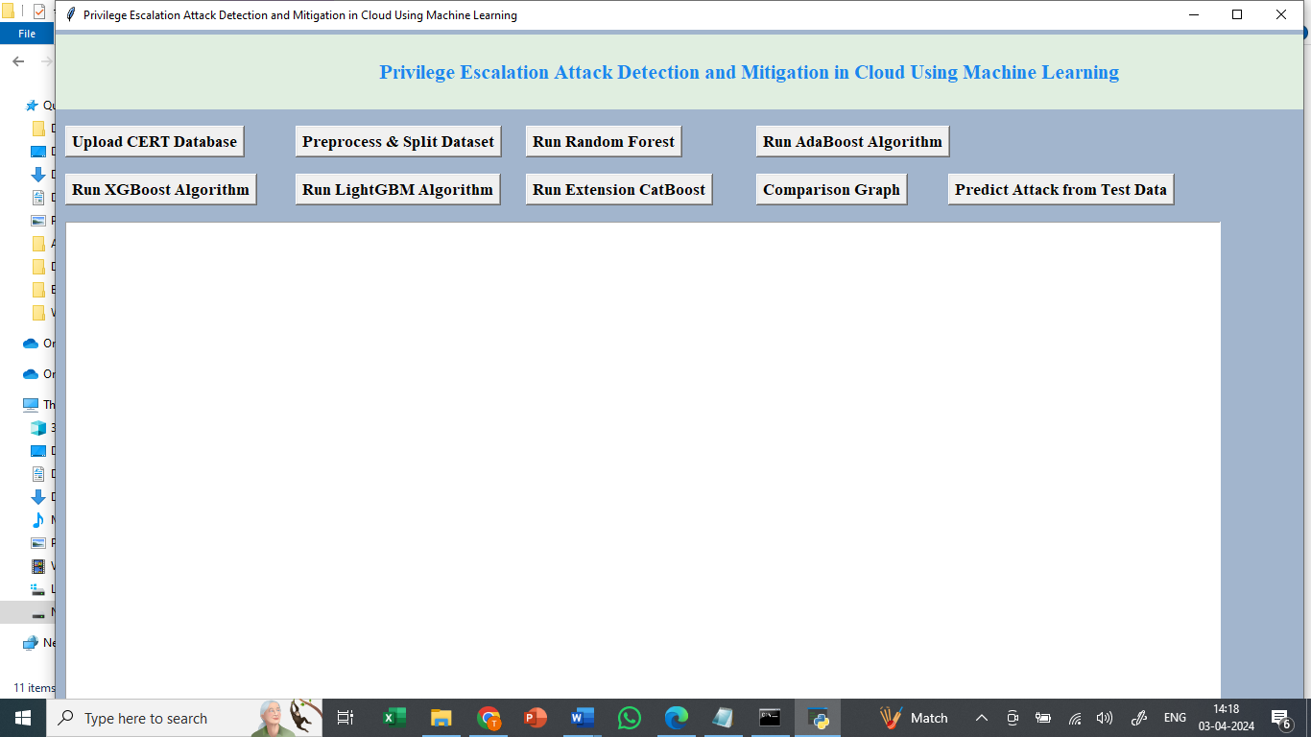
In above screen click on ‘Upload CERT Database’ button to upload dataset and get below page
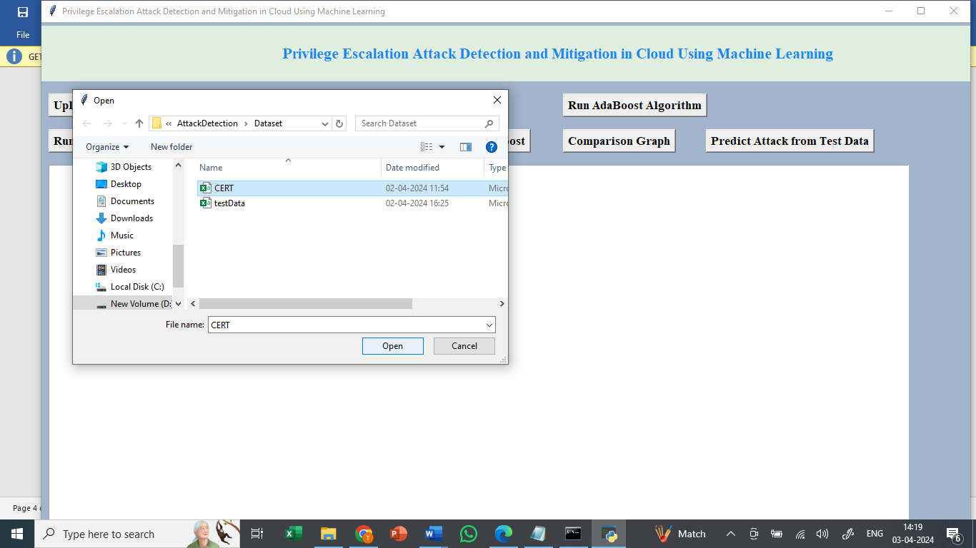
In above screen selecting and uploading ‘CERT’ dataset file and then click on ‘Open’ button to load dataset and get below page
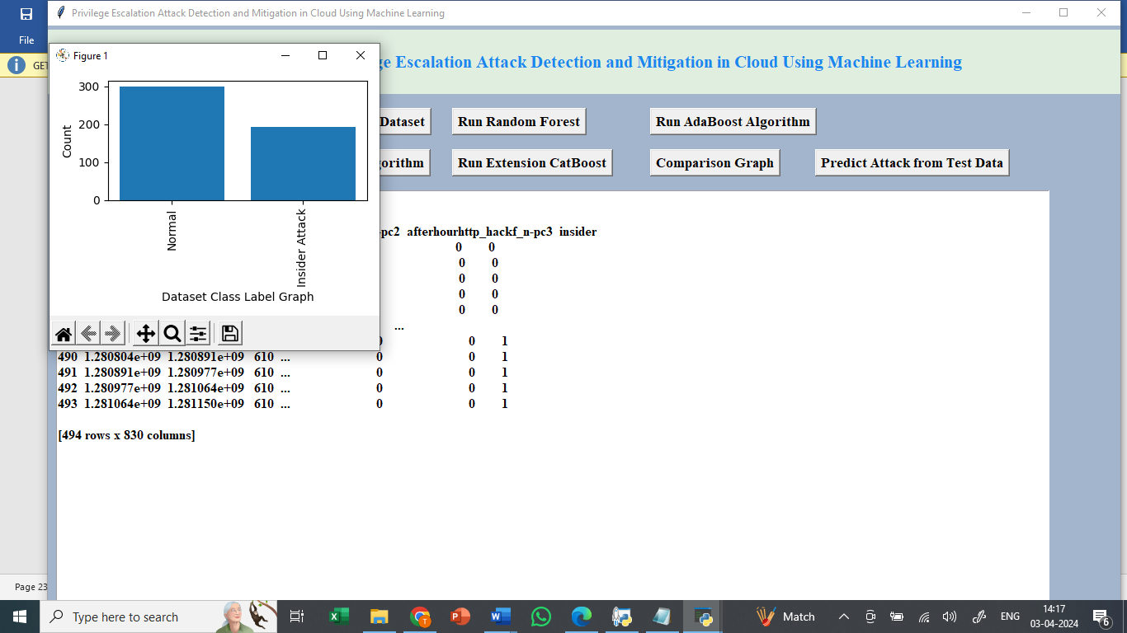
In above screen can see dataset loaded and can see dataset contains 830 columns and in graph x-axis represents class label types and y-axis represents number of instances under that class label and now click on ‘Pre-process & Split Dataset’ button to process dataset and get below page
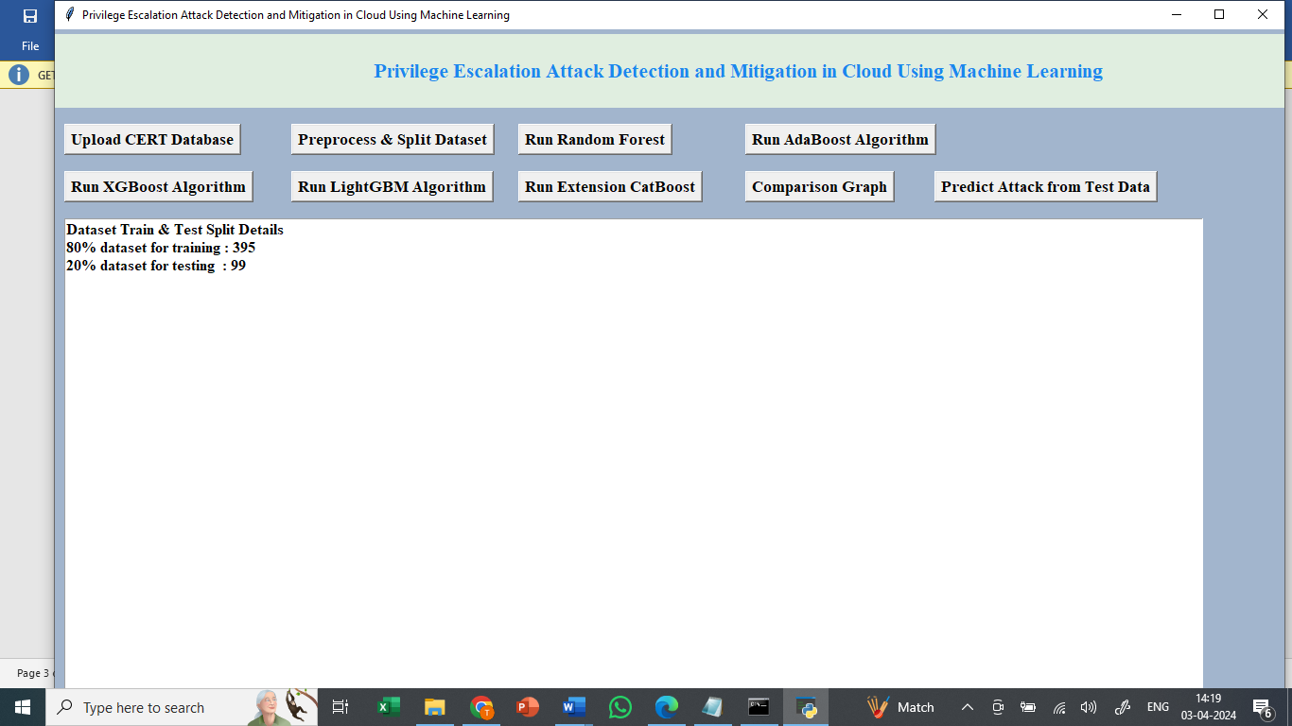
In above screen dataset processing completed and can see train and test size and now click on ‘Run Random Forest’ button to train Random Forest and get below output
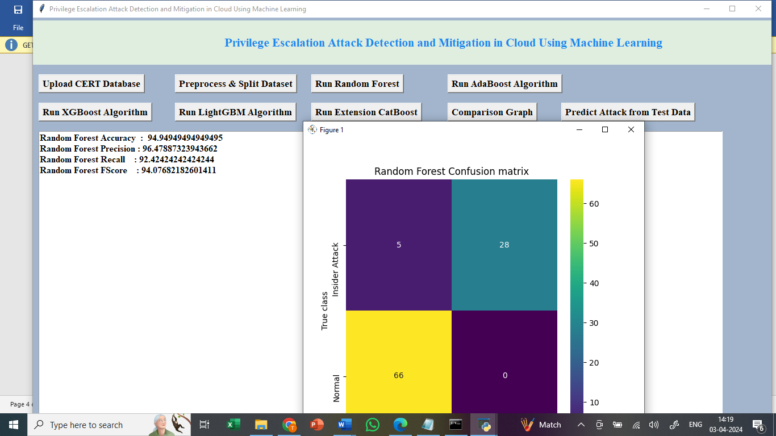
In above screen Random Forest got 92% accuracy and can see other metrics also and in confusion matrix graph x-axis represents Predicted Labels and y-axis represents True Labels and then yellow and green boxes in diagnol represents correct prediction count and blue boxes contains incorrect prediction count and now click on ‘Run ADABOOST’ button to get below output
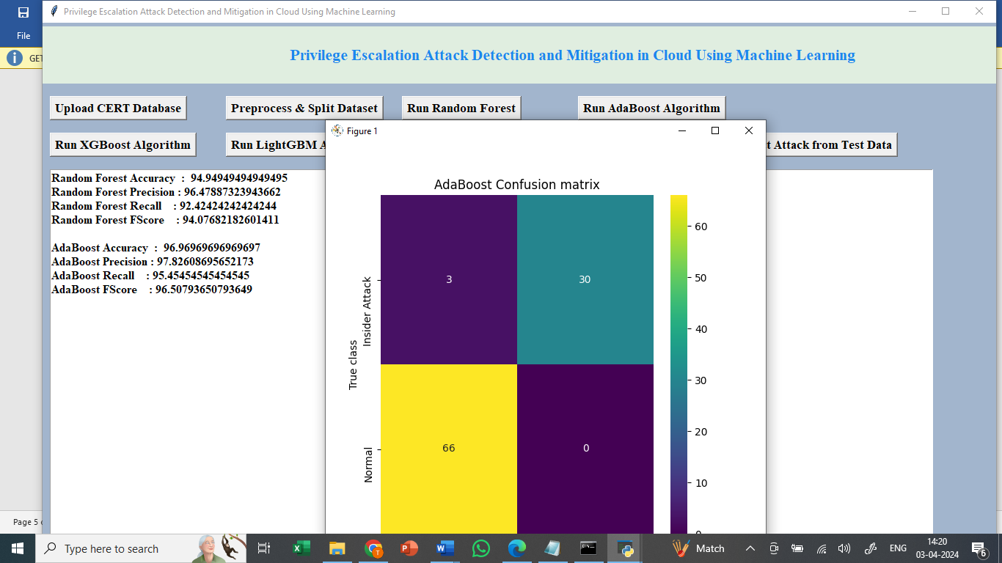
In above screen can see ADABOOST performance and now click on ‘Run XGBOOST’
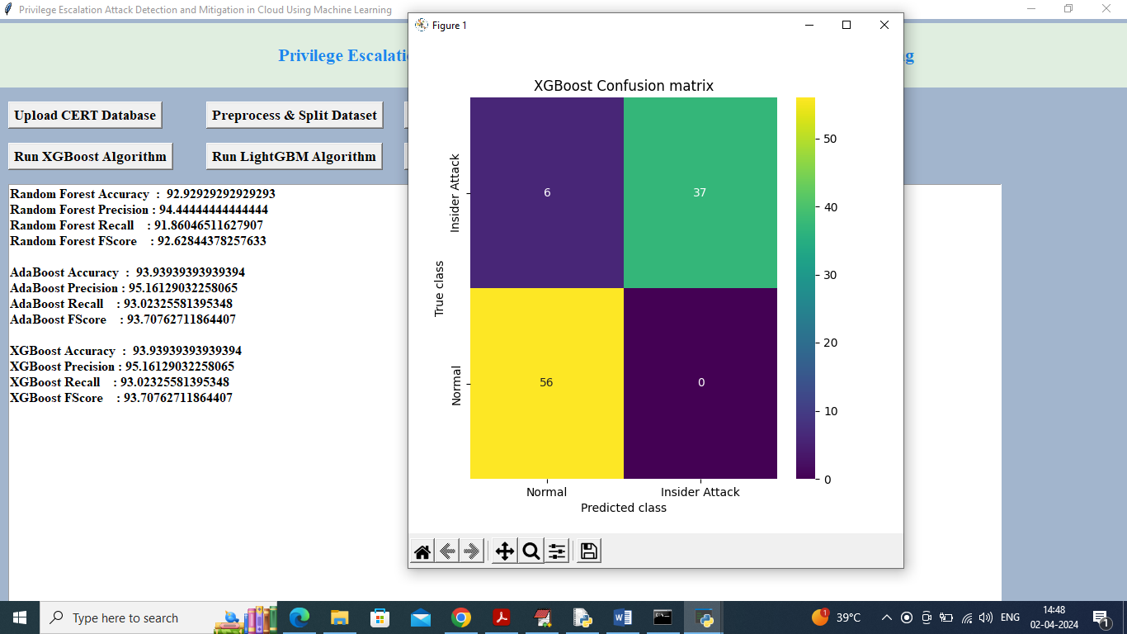
In above screen can see XGBOOST performance and now run LIGHTGBM
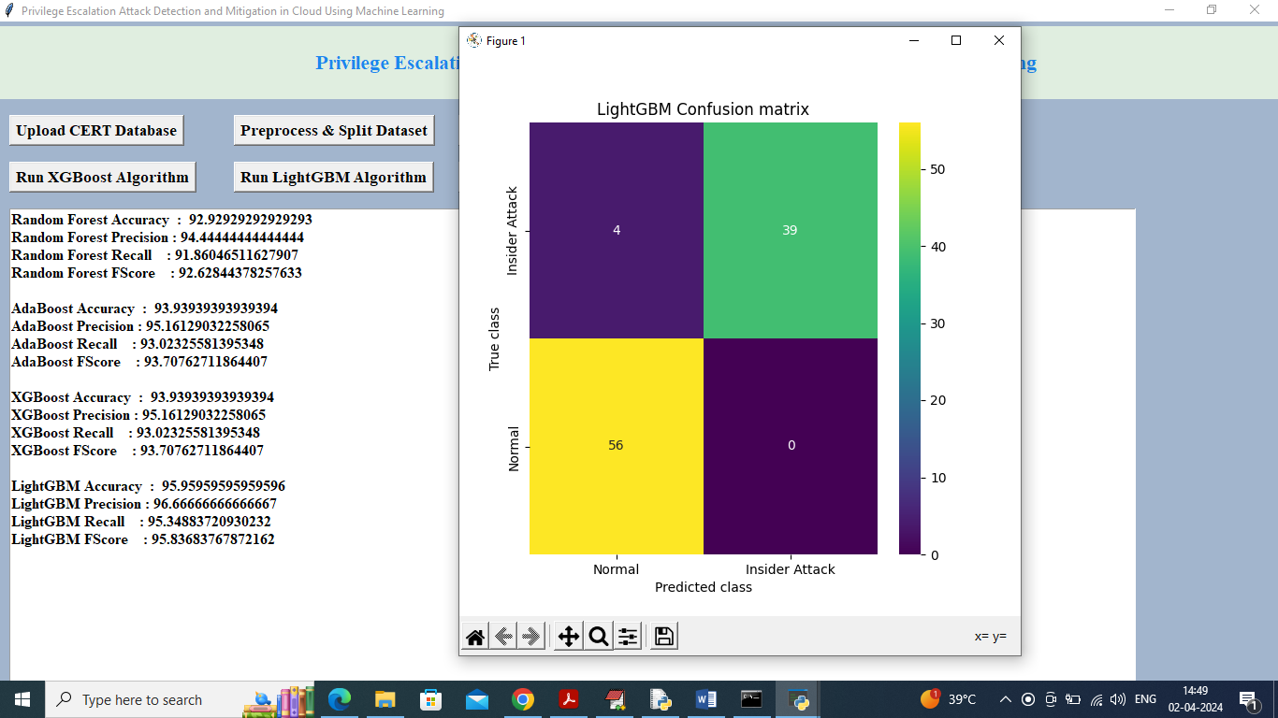
In above screen LIGHTGBM got 95% accuracy and now run CATBOOST algorithm to get below output
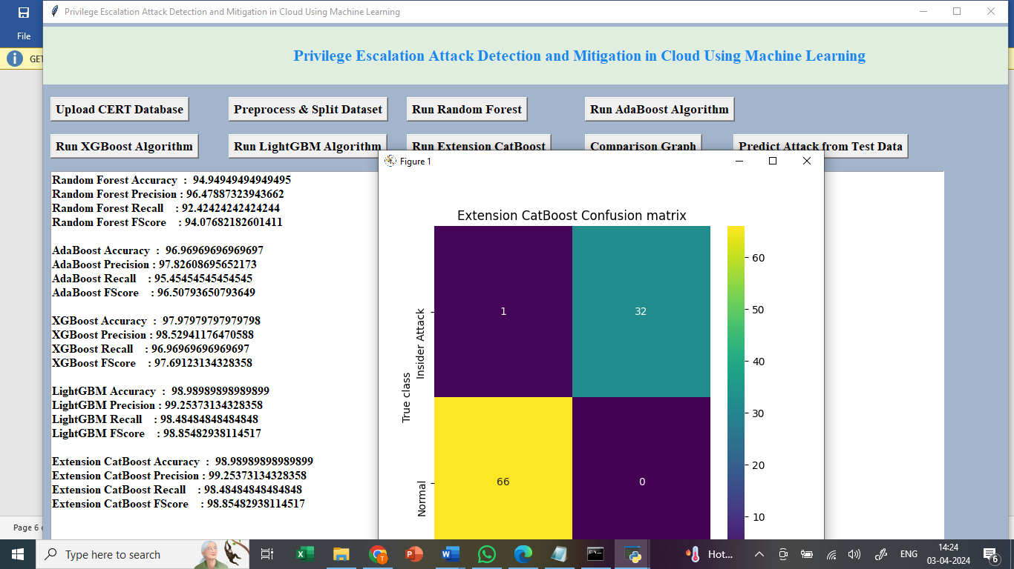
In above screen extension CATBOOST got 97% accuracy and now click on ‘Comparison Graph’ button to get below graph
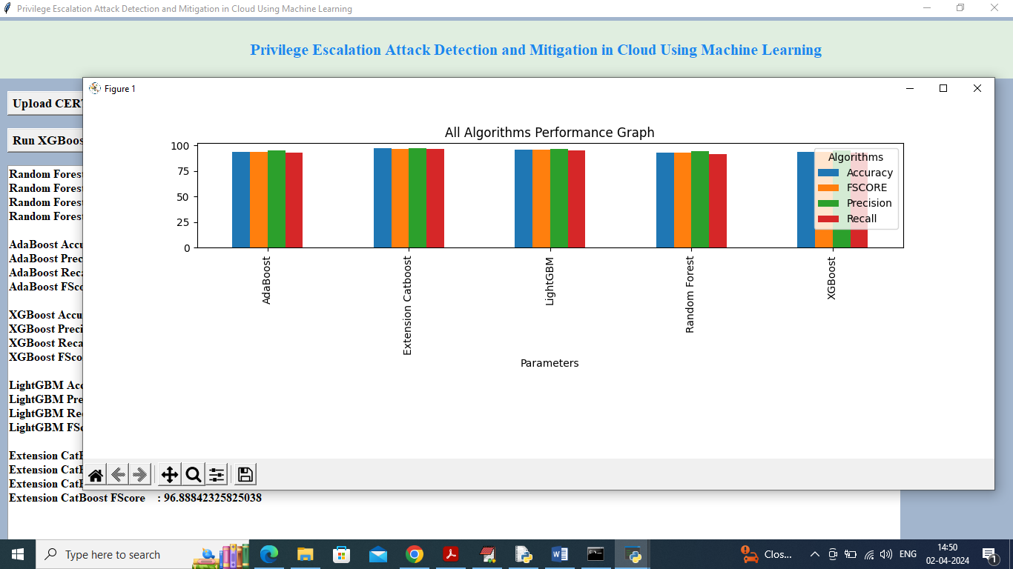
In above graph x-axis represents algorithms names and y-axis represents accuracy and other metrics in different colour bars and in all algorithms extension got high performance. Now Click on “Predict Attack from Test Data”
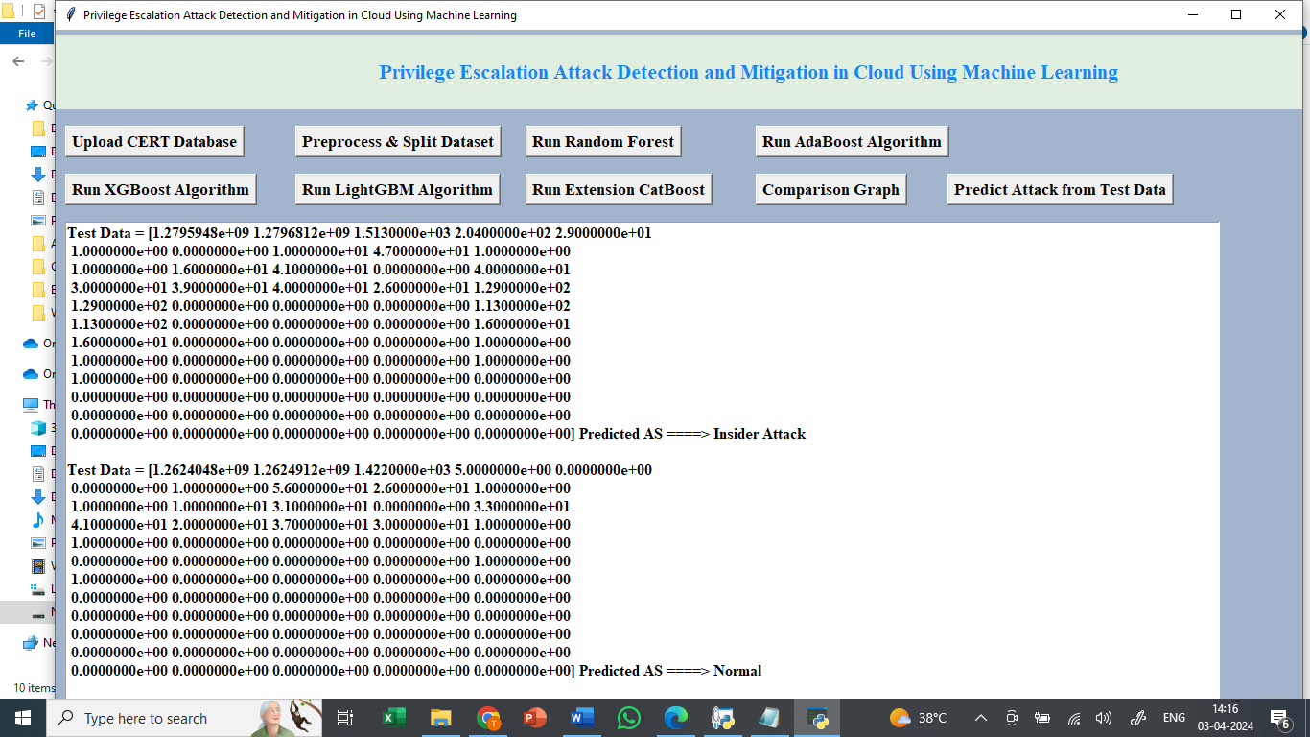
In above screen using extension algorithms we got the predicted value from the Test data as normal or Insider Attack.

8. CONCLUSION:
The malicious insider becomes a crucial threat to the organization since they have more access and opportunity to produce significant damage. Unlike outsiders, insiders possess privileged and proper access to information and resources. This paper proposed machine learning algorithms for detecting and classifying an insider attack. A customized dataset from multiple files of the CERT dataset is used in this work. Four machine learning algorithms were applied to that dataset and gave better results. These algorithms are Random Forest, AdaBoost, XGBoost, and LightGBM. Using these supervised machine learning algorithms, this paper demonstrated the effective experimental results having higher accuracy in the classification report. Among the proposed algorithms, the LightGBM algorithm provides the highest accuracy of 97%; the other accuracy values are RF with 86%, AdaBoost with 88%, and XGBoost with 88.27%. In the future, the proposed models may increase their performance by expanding the dataset in size and diversity in terms of its features and the new trends of insider attackers to perform the attack. This may open up new research trends toward detecting and classifying insider attacks related to many fields of organization. Machine learning models are used by businesses to make credible business decisions, and improved model results lead to better judgments. The cost of mistakes can be quite high, however, this cost is reduced by improving model accuracy. ML-based research enables users to provide massive amounts of data to computer algorithms, which then evaluate, recommend, and decide using the supplied data.
9. REFERENCES:
[1] U. A. Butt, R. Amin, H. Aldabbas, S. Mohan, B. Alouffi, and A. Ahmadian, ‘‘Cloud-based email phishing attack using machine and deep learning algorithm,’’ Complex Intell. Syst., pp. 1–28, Jun. 2022.
[2] D. C. Le and A. N. Zincir-Heywood, ‘‘Machine learning based insider threat modelling and detection,’’ in Proc. IFIP/IEEE Symp. Integr. Netw. Service Manag. (IM), Apr. 2019, pp. 1–6.
[3] P. Oberoi, ‘‘Survey of various security attacks in clouds based environments,’’ Int. J. Adv. Res. Comput. Sci., vol. 8, no. 9, pp. 405–410, Sep. 2017.
[4] A. Ajmal, S. Ibrar, and R. Amin, ‘‘Cloud computing platform: Performance analysis of prominent cryptographic algorithms,’’ Concurrency Comput., Pract. Exper., vol. 34, no. 15, p. e6938, Jul. 2022.
[5] U. A. Butt, R. Amin, M. Mehmood, H. Aldabbas, M. T. Alharbi, and N. Albaqami, ‘‘Cloud security threats and solutions: A survey,’’ Wireless Pers. Commun., vol. 128, no. 1, pp. 387–413, Jan. 2023.
[6] H. Touqeer, S. Zaman, R. Amin, M. Hussain, F. Al-Turjman, and M. Bilal, ‘‘Smart home security: Challenges, issues and solutions at different IoT layers,’’ J. Supercomput., vol. 77, no. 12, pp. 14053–14089, Dec. 2021.
[7] S. Zou, H. Sun, G. Xu, and R. Quan, ‘‘Ensemble strategy for insider threat detection from user activity logs,’’ Comput., Mater. Continua, vol. 65, no. 2, pp. 1321–1334, 2020.
[8] G. Apruzzese, M. Colajanni, L. Ferretti, A. Guido, and M. Marchetti, ‘‘On the effectiveness of machine and deep learning for cyber security,’’ in Proc. 10th Int. Conf. Cyber Conflict (CyCon), May 2018, pp. 371–390.
[9] D. C. Le, N. Zincir-Heywood, and M. I. Heywood, ‘‘Analyzing data granularity levels for insider threat detection using machine learning,’’ IEEE Trans. Netw. Service Manag., vol. 17, no. 1, pp. 30–44, Mar. 2020.
[10] F. Janjua, A. Masood, H. Abbas, and I. Rashid, ‘‘Handling insider threat through supervised machine learning techniques,’’ Proc. Comput. Sci., vol. 177, pp. 64–71, Jan. 2020.
[11] R. Kumar, K. Sethi, N. Prajapati, R. R. Rout, and P. Bera, ‘‘Machine learning based malware detection in cloud environment using clustering approach,’’ in Proc. 11th Int. Conf. Comput., Commun. Netw. Technol. (ICCCNT), Jul. 2020, pp. 1–7.
[12] D. Tripathy, R. Gohil, and T. Halabi, ‘‘Detecting SQL injection attacks in cloud SaaS using machine learning,’’ in Proc. IEEE 6th Int. Conf. Big Data Secur. Cloud (BigDataSecurity), Int. Conf. High Perform. Smart Comput., (HPSC), IEEE Int. Conf. Intell. Data Secur. (IDS), May 2020, pp. 145–150.
[13] X. Sun, Y. Wang, and Z. Shi, ‘‘Insider threat detection using an unsupervised learning method: COPOD,’’ in Proc. Int. Conf. Commun., Inf. Syst. Comput. Eng. (CISCE), May 2021, pp. 749–754.
[14] J. Kim, M. Park, H. Kim, S. Cho, and P. Kang, ‘‘Insider threat detection based on user behavior modeling and anomaly detection algorithms,’’ Appl. Sci., vol. 9, no. 19, p. 4018, Sep. 2019.
[15] L. Liu, O. de Vel, Q.-L. Han, J. Zhang, and Y. Xiang, ‘‘Detecting and preventing cyber insider threats: A survey,’’ IEEE Commun. Surveys Tuts., vol. 20, no. 2, pp. 1397–1417, 2nd Quart., 2018.
[16] P. Chattopadhyay, L. Wang, and Y.-P. Tan, ‘‘Scenario-based insider threat detection from cyber activities,’’ IEEE Trans. Computat. Social Syst., vol. 5, no. 3, pp. 660–675, Sep. 2018.
[17] G. Ravikumar and M. Govindarasu, ‘‘Anomaly detection and mitigation for wide-area damping control using machine learning,’’ IEEE Trans. Smart Grid, early access, May 18, 2020, doi: 10.1109/TSG.2020.2995313.
[18] M. I. Tariq, N. A. Memon, S. Ahmed, S. Tayyaba, M. T. Mushtaq, N. A. Mian, M. Imran, and M. W. Ashraf, ‘‘A review of deep learning security and privacy defensive techniques,’’ Mobile Inf. Syst., vol. 2020, pp. 1–18, Apr. 2020.
[19] D. S. Berman, A. L. Buczak, J. S. Chavis, and C. L. Corbett, ‘‘A survey of deep learning methods for cyber security,’’ Information, vol. 10, no. 4, p. 122, 2019.
[20] N. T. Van and T. N. Thinh, ‘‘An anomaly-based network intrusion detection system using deep learning,’’ in Proc. Int. Conf. Syst. Sci. Eng. (ICSSE), 2017, pp. 210–214.
[21] G. Pang, C. Shen, L. Cao, and A. V. D. Hengel, ‘‘Deep learning for anomaly detection: A review,’’ ACM Comput. Surv., vol. 54, no. 2, pp. 1–38, Mar. 2021.
[22] A. Arora, A. Khanna, A. Rastogi, and A. Agarwal, ‘‘Cloud security ecosystem for data security and privacy,’’ in Proc. 7th Int. Conf. Cloud Comput., Data Sci. Eng., Jan. 2017, pp. 288–292.
[23] L. Coppolino, S. D’Antonio, G. Mazzeo, and L. Romano, ‘‘Cloud security: Emerging threats and current solutions,’’ Comput. Electr. Eng., vol. 59, pp. 126–140, Apr. 2017.
[24] M. Abdelsalam, R. Krishnan, Y. Huang, and R. Sandhu, ‘‘Malware detection in cloud infrastructures using convolutional neural networks,’’ in Proc. IEEE 11th Int. Conf. Cloud Comput. (CLOUD), Jul. 2018, pp. 162–169.
[25] F. Jaafar, G. Nicolescu, and C. Richard, ‘‘A systematic approach for privilege escalation prevention,’’ in Proc. IEEE Int. Conf. Softw. Quality, Rel. Secur. Companion (QRS-C), Aug. 2016, pp. 101–108

